Student Name: Derek Leung

Student ID: 3427064

1. Website screencap

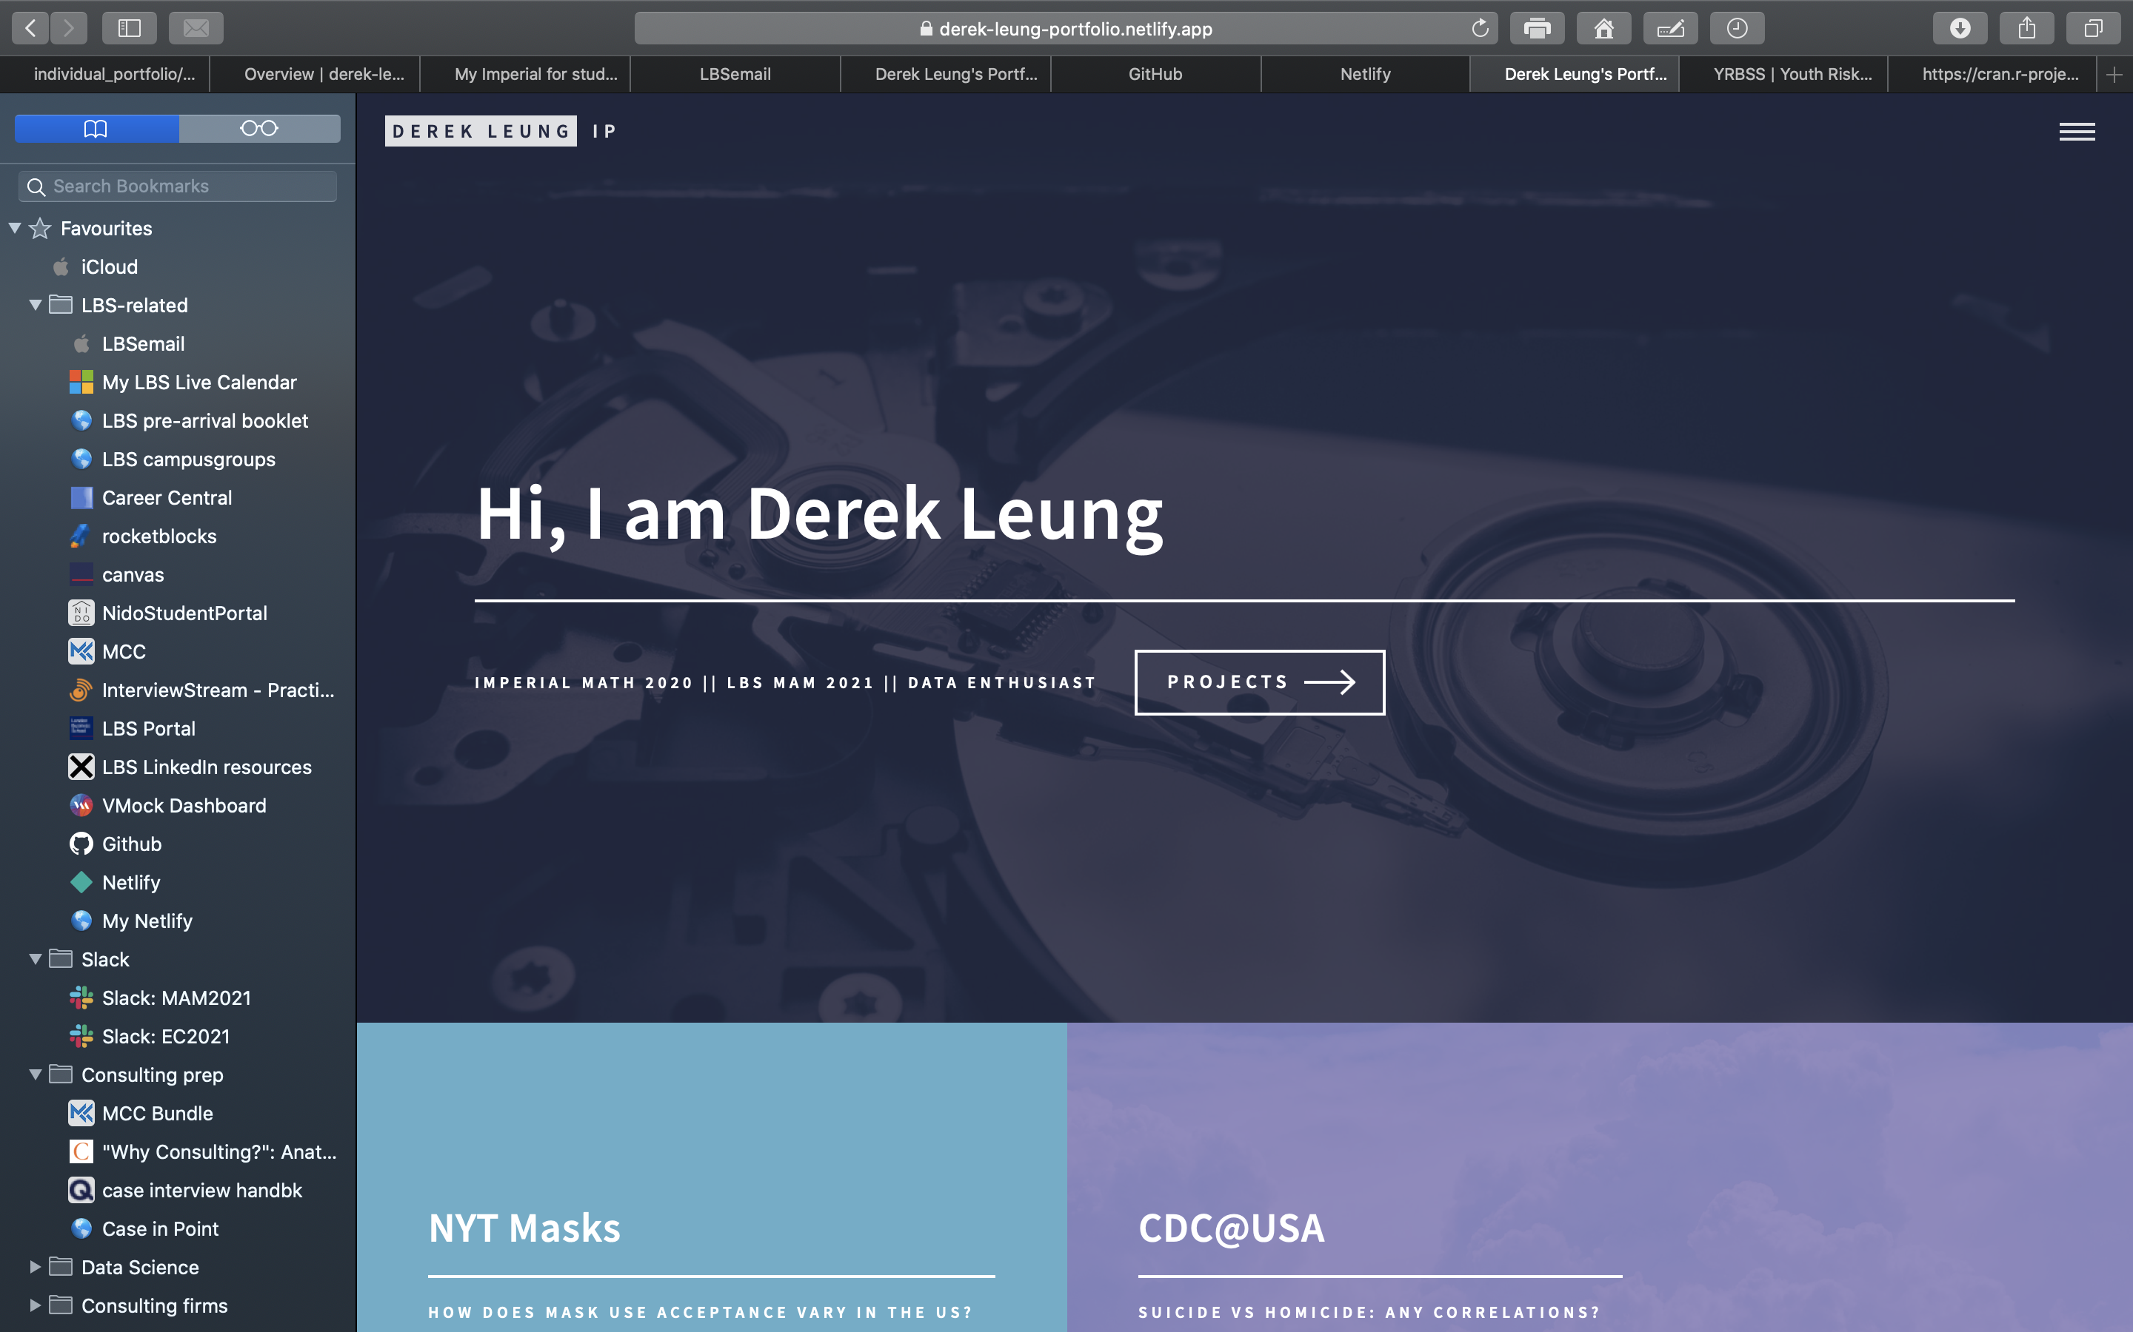

1. Github screenshot

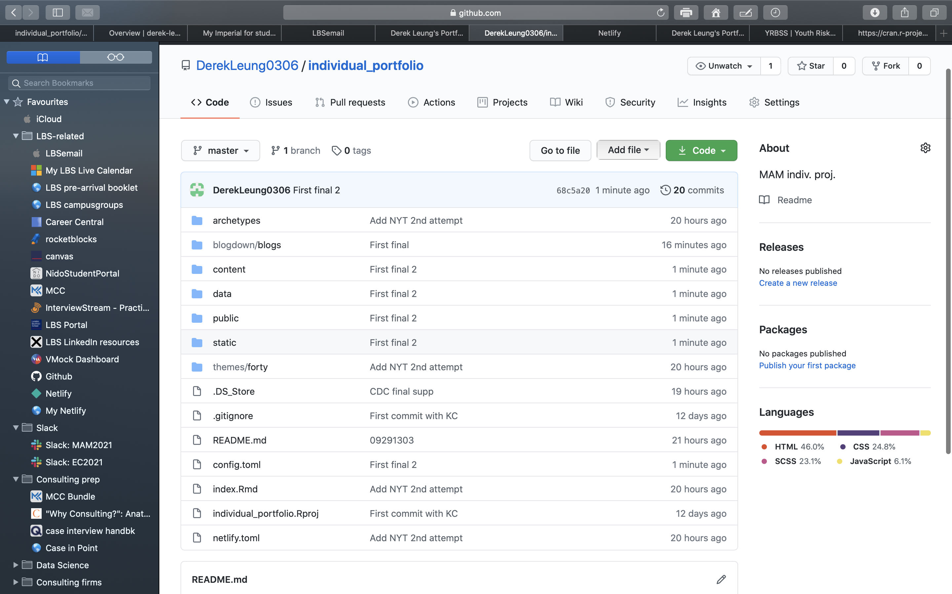

1. Netlify screenshot

